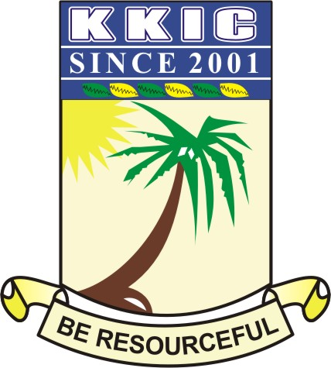

|  |  |  |  |  |  |
| --- | --- | --- | --- | --- | --- |
| **NAME** |  | | | | |
| **SUBJECT** | **HISTORY** | **CLASS** | **JSS 1** | **DURATION** | **1 HR 30mins** |

**PAPER 1- OBJECTIVES (20 Marks)**

**INSTRUCTION: Answer all Questions**

1. An annual fishing festival common among the Tiv people of Nigeria is called _____

1. Arugungu
2. Kata
3. Yankaree
4. Games

2. _________ is the political head of the Nupe people

A. Oba

B. Ooni

C. Etsu

D. Obi

3. The first NOK artifacts were discovered in ______

A. 1938

B. 1928

C. 1958

D. 1948

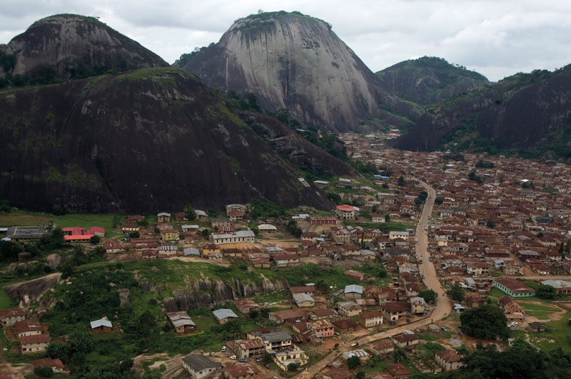

**Use the image above to answer questions 4 – 6**

4. The above image is known as the Oke Idanre hills, it can be found in ______ state of Nigeria.

1. Ondo
2. Edo
3. Ekiti
4. Ogun

5. The hill in the image has _______ steps

1. 680
2. 660
3. 670
4. 640

6. The hill has the palace of the town and he is addressed as ________

A. Etsu

B. Obi

C. Ooni

D. Owa

7. Which of the following is the current president of Nigeria?

A. Adam Oshiomole

B. Bola Ahmed Tinubu

C. Muhamed Buhari

D. Godwin Emeiefele

8. The first king of Ile-Ife was _______

A. Oranmiyan

B. Oduduwa

C. Ooni

D. Okanbi

9. All of these practiced a centralised system of government except _________

1. Nupe
2. Delta city states
3. Igala kingdom
4. Igbo

10. There are many accounts on the origin of many Nigerian groups because the early Nigerian people _______________

1. were confused about their origin
2. lacked a system of writing
3. could not remember their origin
4. are not proud of their origin

11. The people of Igbo –Ukwu speak _______ language

1. Igbo
2. Ukwu
3. Benin
4. Hausa

12. The type of history that deals with issues such as marriage and age grade is called ________

1. Cultural history
2. Religious history
3. Social history
4. Military history

13. The Nok art works were named after the Nok village by _________

A. Bola Ahmed Tinubu

B. Benard Fagg

C. Dent Young

D. Lord Fredrick Lugard

14. One of the differences between history and stories is _____________

1. history deals with fact and figure
2. history deals with imagined events
3. history is about ancient folklores
4. history is not an academic field of study

15. Which of these was not part of Igbo – Ukwu artifacts?

1. Rope pot
2. Cooper anklets
3. Iron head of the King
4. Strings of beads

16. The Nok people were significant with which of the following?

1. stone
2. wood
3. iron
4. river

17. The first storey building in Nigeria can be found in __________

1. Aso Rock
2. Badagry
3. Calabar
4. Owerri

18. Which of the following statements is not true about primary sources of history?

1. The information is real
2. The information is more reliable
3. It may be useful for further research
4. It is very easy and cheap to get.

19. The lost wax can be identified with the _______ people.

1. Hausa
2. Ife
3. Fulani
4. Igbo-Ukwu

20. All the following are the characteristics of a centralized state except_________

1. power resides at the central
2. Flexible constitution
3. Single executive
4. power resides at the central

21. Prince in Yoruba land is called _____________

A. Aremo

B. Mai

C. Alaafin

D. Kabiyesi

22. The lines on Ife terracotta are called _______

1. striation
2. cut
3. decoration
4. all of the above

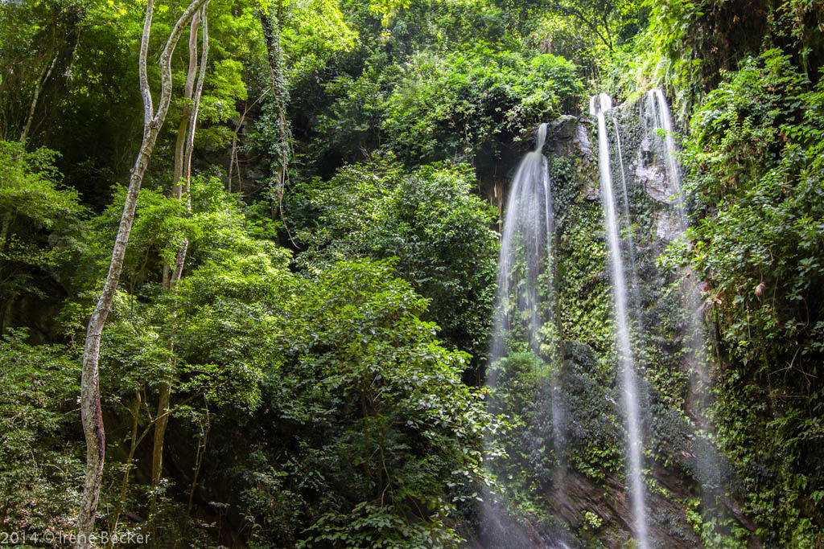

**Use the image above to answer questions 23 -26**

23. The ancient structure in the picture above is known as Erin Ijesha water falls, it also known as__________

**A. Olumirin water fall**

B. Ikogosi wam spring

C. Kangi dam water fall

D. Ero water falls

24. The above water fall was discovered by ______

1. Mungo Park
2. Akinla, Oduduwa’s ground-daught
3. Sango Elempe
4. Tafawa Balewa

25. In 2024 the above historical site attracted over _______ tourists.

A. 40, 000

B. 50, 000

C. 70,000

D. 30,000

26. The natives regard the waterfall as a sacred site and a means of ________their souls.

A. soaping

B. purifying

C. punishing

D. denting

27. The word “historia” is a _________word

1. Latin
2. Spanish
3. Hindu
4. Greek

28. ___________ is the father of objective history

1. Abraham
2. Thucydides
3. Adam
4. Herodotus

29. Which of the following has similar culture with the Benin people?

A. Ife

B. Tiv

C. Kano

D. Igbo

30. ________ is the major occupation of the Niger Delta people

1. Farming
2. Fishing
3. Iron smelting
4. Lumbering

31. Terracotta is another word for __________

1. moulded iron
2. carved stone
3. baked clay
4. beads

32. Historical knowledge is important because _________

1. it makes us civilized
2. educate us on how to live like the Romans
3. it is the foundation for progress
4. our parents love history

33. A place where relics are kept is called _______

1. musuem
2. school
3. monastery
4. hostel

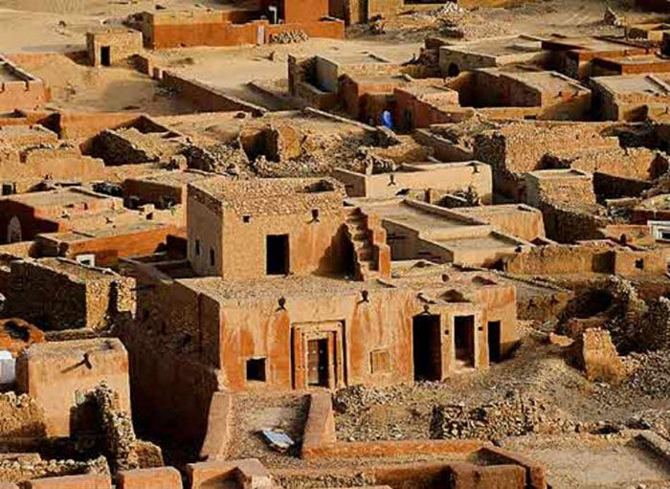

**Use the image above to answer questions 34 – 36**

34. The picture above shows the ________ settlement

1. Benin
2. Tiv
3. Nok
4. Nupe

35. The first artifact from the settlement above was discovered by ___________

A. General Babangida

B. Colonel Dent Young

C. Oduduwa

D. Oba of Lagos

36. Historical evidence showed that NOK people were very skillful in __________

1. Iron work
2. Brass work
3. Bronze work
4. Aluminium work

37. Ife is known mainly for its ____________

1. bronze work
2. stone carved work
3. brass Work
4. copper work

38. What is the full meaning of (C.M.S)

1. Church Missionary Society
2. Church Mission Society
3. Chapel Missionary Society
4. Chapter Missionary State

39. The major language of Benin people is ________

1. Bini language
2. Edo language
3. Ibini language
4. Benin language

40. Nigeria has ______ geo-political zones.

1. four
2. five
3. six
4. seven

41. There are ______ steps to descend to Ogbunike cave

1. 316
2. 317
3. 322
4. 320

42. In which state in Nigeria can Igbo-Ukwu be found?

1. Edo state
2. Abia State
3. Delta State
4. Anambra state

43. Nigeria is in which continent?

A. Australia

B. America

C. Africa

D. Asia

44. History satisfies one’s _________

A. hunger

B. feeling

C. curiosity

D. sight

45. Nigeria became a Republican nation in _______

A. 1914

B. 1960

C. 1963

D. 1941

46. Cattle rearing are common to ______ part of Nigeria

A. Northern

B. Southern

C. Eastern

D. Western

47. The king of Oyo is addressed as ________

A. Ooni of Ife

B. Aero of Ekiti

C. Oba of Benin

D. Alaafin of Oyo

48. The National war museum is located in _______ state

A. Akwa Ibom

B. Abia

C. Anambra

D. Imo

49. The Igbo-Ukwu history can be traced to _______

A. Professor Wole Soyinka

B. Professor Flora Shaw

C. Professor Thursan Shawn

D. Professor Henry Townsend

50. Which of the following has the oldest culture in Nigeria?

A. Benin

B. Nok

C. Ife

D. Igbo-Ukwu

**Paper 2: Theory**

**Instruction: Answer question 1 and any other three questions of your choice**

1. Define the term centralised state. **2 MARKS**

(b) Mention 5 characteristics of a centralised state

**5 MARKS**

(c) Explain any 3 mentions above **3 MARKS**

2. Discuss the Tiv people of Nigeria. **3 MARKS**

(b) List 4 disadvantages of a non-centralised state.

**4 MARKS**

(c) Mention 3 characteristics of a non-centralised state **3 MARKS**

3. Write the title of the following kings in the following places of Nigeria:

(i) Oke Idanre

(ii) Nupe kingdom

(iii) Hausa land

(iv) Oyo Empire

(v) Calabar **5 MARKS**

(b) Write 5 similarities between Oyo and Nupe Empire **5 MARKS**

4. Write 5 similarities between Ife and Benin Empire

**5 MARKS**

(b)Mention three importance of history.

**3 MARKS**

(c) Write 2 advantages of a centralised state

**2 MARKS**

5. In a tabular form. 4 differences between Hausa and the Kanem-Bornu Empires **4 MARKS**

(b) Give 3 differences between Igbo and Niger Delta city states. **3 MARKS**

(c) Mention 3 similarities between Igbo and Niger Delta city states. **3 MARKS**